Hi everyone, welcome to
University English Truth Class One.

First of all let me introduce myself. My name is:


Ryan!!!!!

The first thing I want to let you know is how to contact me. The best way is by phone/
Kakaotalk.

If you can, add my phone number now: 010-4294-8877.

Or you could add my Kakaotalk ID: ryanfitzy

Kakaotalk or text message is faster than e-mail, and sometimes student e-mails go to my junk mail ㅠㅠ

Here are the textbooks we will be using:
For speaking
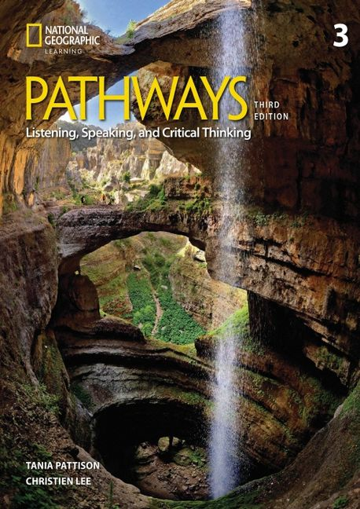

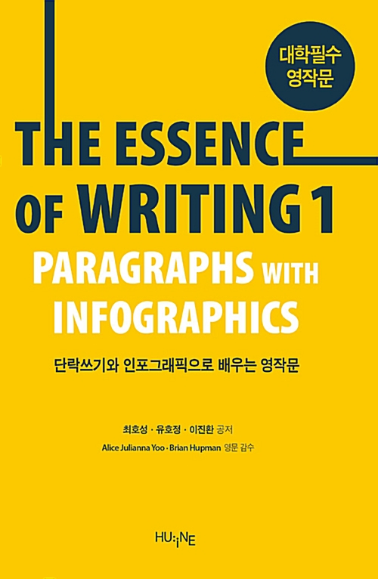
For writing

How the class will be graded:

With University English classes, your total grade is your Korean Professor’s score + Ryan’s score +attendance:

Korean Professor 40%
Ryan 50%
Attendance 10%
TOTAL 100%

For Ryan’s Class:
(Note - this could change because of other factors)

Mid-term test 4월 10%
Final test 6월 10%
Speaking assessment 15%
Participation/Attendance/
Homework 15%

Total 50%

Tests will be mostly based on the Pathways/Writing Textbook and classwork.

Speaking assessment will be individual or group speaking

Participation = listening in class, trying to speak in English, doing group work, answering or asking questions, no sleeping or too much time on phone/devices

Attendance = coming to class on time, not missing classes

A lot of your grade is based on EFFORT and PARTICIPATION. Your English level is not so important. Trying to practice, use English and improve IS important!

QUESTIONS!!!

I LOVE QUESTIONS. It shows me students are interested or are thinking about the class. Also it’s a good way to practice English. So if you ever have any questions, Kakaotalk me!

Do not feel scared or worried. Stupid questions are ok too!
I will do my best to help you^^

